Name: Sanika Botre PRN: 25070122063
Batch: 2025-29 Branch: CSE A-2
Subject: Programming with Java

ASSIGNMENT No: 8

TITLE : Write a Java program to demonstrate the use of the super keyword in inheritance.

Problem Statement: Write a Java program to demonstrate the use of the super keyword in inheritance.

Learning Objectives: To demonstrate the use of the super keyword for accessing parent class members.

Theory:

The super keyword is used to refer to the immediate parent class in Java. It can invoke parent class constructors, access parent class variables, and call overridden methods. Super helps distinguish between parent and child class members with the same name. It ensures proper constructor chaining during object creation. It is an important concept in inheritance and method overriding.

Exercise:

1. Create an Employee and Manager program where Manager accesses Employee details using super keyword.

Code:-

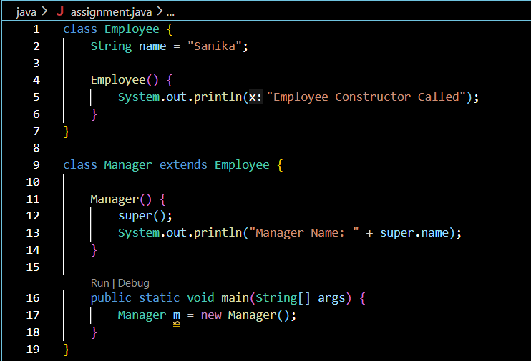

Output:-

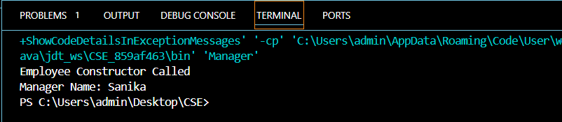

2. Develop a Vehicle Insurance System where child insurance classes access parent vehicle information using the super keyword.

Code:-

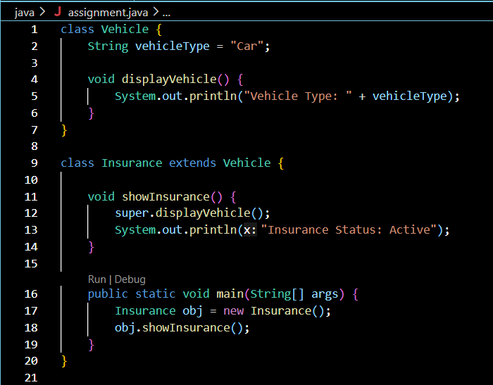

Output:-

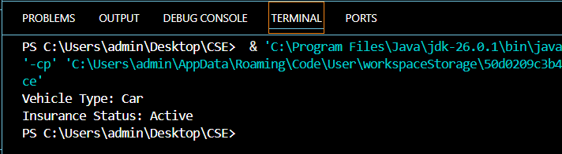

Conclusion:

This assignment successfully demonstrated the use of the super keyword in Java. It showed how super is used to access parent class constructors, variables, and methods within a derived class. The programs executed successfully and illustrated the relationship between parent and child classes using inheritance. Overall, this assignment improved the understanding of inheritance and the practical use of the super keyword in object-oriented programming.

